Risk Management Plan

Version:
6

Author/Owner:
Manager Safety, Risk & Resilience /
General Manager People & Business Services

Contents
1. Contents 2
2. Document version history 3
3. Introduction, Purpose and Scope 4
4. Risk Management Framework 4
5. Risk Appetite and Permission Statements 5
6. Risk Management Goals and Objectives 6
7. Definition of Risk 6
8. Risk Governance 6
9. Roles, Responsibilities & Resources 7
10. Risk Management Process 8
10.1. Communication and Consultation 8
10.2. Scope, Context and Criteria 9
10.2.1 Defining the Scope 9
10.2.2 Risk Types 9
10.2.3 External and Internal Context 10
10.2.4 Criteria 11
Impact Categories 11
10.3. Risk Identification 11
10.4. Sources of Risk 11
10.5. Risk Evaluation 12
10.6. Risk Treatment 13
10.6.1 Selecting risk treatment options 13
10.6.2 Risk Treatment Plans 14
10.7. Risk Response 14
10.8. Monitoring and Review 14
10.8.1 Strategic Risks 14
10.8.1 Operational & Project Risks 15
10.9. Recording and Reporting 15
10.9.1 Strategic Risks 15
10.9.2 Operational Risks 16
11. Key Risk Management Activities 17
12. References 18

Document version history

Version | Changes made to document
2.1 | Plan Approved by Executive and uploaded
3 | Annual Review, updates and approved by Executive.
4 | - Plan Approved by Executive  - Updated plan to reflect Victorian Government Risk Framework (page 8) Replaced the term inter agency risk with shared risk in line with the updated VGRMF  - Minor amendments made to pages 5, 8,12,13,14 detailing Risk treatment, treatment plans and reporting.  - Page 15 updated to reflect key risk activities
5 | - Annual Review, updates and approved by Executive  - Updated plan to reflect Hazard Reporting / Management as a key IMS system where Risk Management is integrated into – page 4  - Added IT as a consequence category - page 7  - Replaced DELWP with the updated agency name DEECA – page 8, 16  - Moved timeline to explore opportunity risk out to Nov 2024 to prioritise implementation of operational risks – page 15  - Updated reference to Victorian Government Risk Management Framework – page 16  - Updated to the new SoControl template
6 | - Annual Review, updates and approved by Executive  - Introduction Purpose and Scope - Page 3. Changed from Introduction. Added requirements for Certification to ISO Standards (14001 and 45001)  - 1. Risk Management Framework – Page 4. Removed description of principle elements. Added detail on Wannon Water specific elements and systems/processes which support the framework  - 2. Risk Appetite and Permission Statements – Page 5-6. Moved Board Commitment into this section. Referenced commitment statement in Risk Policy of Board Policy Framework. Added Risk Permission Statements in  - 3. Risk Management Goals and Objectives – Page 7. Added as new section  - 4. Definition of Risk – Page 7. Added as new section  - 7. Risk Management Process – Page 9-17. Added Figure 3 – Process. Reset section numbering to align with process  - 7.1 Communication and Consultation - Page 9. Update processes used to communicate and consult  - 7.2 Scope, Context and Criteria – Page 10-12. Moved Risk Types into to after Scope. Updated processes to defining external context/emerging trends/threats. Added details on criteria acceptance, analysis and evaluation of risk  - 7.4 Sources of Risk – Page 13. Added Materials and Processes as sources of risk  - 7.8 .1 Operational & Project Risks – Page 16. Removed requirement for annual review of risks  - 8. Key Risk Management Activities – P18. Updated Activity list for 2024  - 9. References – Page 19. Added ISO Standard references (14001 and 45001)

Introduction, Purpose and Scope
The purpose of the Risk Management Framework is to assist the organisation in integrating risk management into significant activities and functions and to describe our approach to the management of our strategic and operational risks. These outcomes assist our organisation to achieve our strategic direction.

Beyond water for strong communities.

A systematic approach to risk management is critical in the delivery of our services.

Wannon Water must manage risk in line with our regulatory obligations, in particular section 5-1 in our Statement of Obligations 2015:

“The Corporation must develop and implement plans, systems and processes, having regard to the ISO 31000 Risk Management (or as amended) to ensure that risks associated with functions performed and services provided by the Corporation are identified, assessed, prioritised and managed.”

Under the Standing Direction(s) of the Minister for Finance (3.7.1) we are obligated to apply the Victorian Government Risk Management Framework (VGRMF).

To maintain certification of our Zero Harm management system (to ISO 14001-Environment) and ISO 45001-OHS) we must ensure processes are in place to manage risks and opportunities associated with our activities and compliance obligations.

This framework is applicable to all employees within Wannon Water and all risk types defined within this plan.

Risk Management Framework
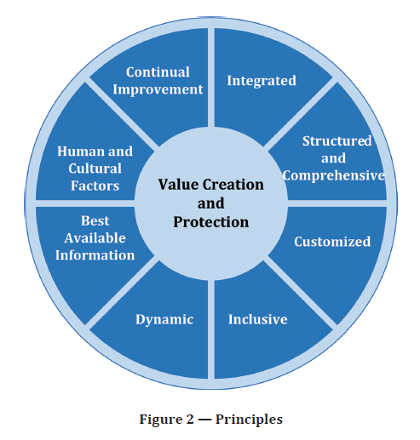
Our risk management framework is based on the principles in ISO 31000:2018.

Figure 1 – Principles (ISO 31000:2018)

The framework consists of the following elements:

- Risk Policy Statement (within the Board Policy Framework. Includes risk appetite)
- Hazard and Risk Management Standard
- Risk Management Plan (this document)
- Risk Management Procedure¹ (and referenced supporting/guidance documents)
- Strategic and operational risk consequence categories (describe the criteria for assessment of risks)
- Strategic and operational risk registers and assessments (as described within the Risk Management Procedure)

The framework is supported by the following systems or processes:
- Strategic and Project Investment Planning processes (incorporate consideration of strategic and operational risk)
- Hazard and Incident registers (within RiskWare)
- Wannon Water Audit Program (provides assurance that risk controls are effective)
- Wannon Water Emergency Management Framework (provides guidance on activities to mitigate, respond to and recover from emergency risks)
- Zero Harm Management System standards and supporting documents (provide further guidance on requirements to manage risk and meet applicable obligations)

Risk Appetite and Permission Statements
We need to take risks to fulfil our strategic intent and we’re careful about when we choose to do this. The Risk Policy Statement which forms part of the Board Policy Framework details the principles, guidance and expectations in how the organisation operates.

The overarching principle is that we will operate within our risk appetite statement:

Wannon Water will accept and manage risks in pursuit of our purpose and strategic direction.

Wannon Water will:
- Be risk averse in relation to physical safety and mental wellbeing of people, drinking water safety and harm to the environment, consistent with our Zero Harm aspiration
- Have a low-risk approach for our customer commitments, reliable water and sewerage services, cyber security and governance systems
- Have a medium risk approach to opportunities to strengthen our region
- Be open to opportunities that have significant potential for increased organisational performance.

Risk Management Goals and Objectives
For the risk management framework to be effective the following goals and objectives have been identified and can be updated and refined as needed:

Goal: To ensure that risks facing our organisation are appropriately managed to support the delivery of our strategic direction and assist decision-making processes.

Objectives: The following are the objectives of the risk management framework;

- Risk management is incorporated into all planning activities
- All employees receive applicable risk management training to improve and maintain their risk management skills
- Risk information is maintained in accordance with specified requirements
- Reports provide information necessary to make risk informed decisions

Definition of Risk
Wannon Water has adopted the following definition of risk.

An event that could/will occur that will impact on organisation objectives. It is measured in terms of likelihood and consequence.

Risk Governance
Forums and mechanisms have been established for the board to oversee the risk management practices across the business (See figure 2), including the implementation of a sound Risk Management Framework.

Risk governance is well established at both board level and within the organisation. Members with adequate skill sets and competencies to provide an appropriate level of oversight from a risk management perspective compose the Board and Committees, including obtaining assurance over the operation of approved risk management procedures.

Risk is a recurring agenda item at Board and Executive Management level.

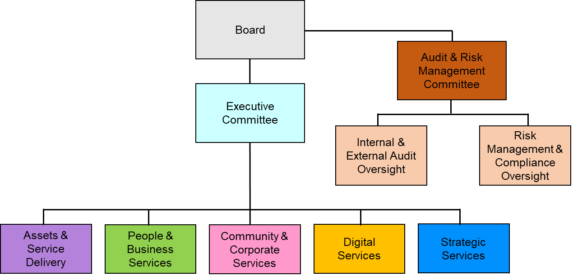
Figure 2 - Board Oversight

Roles, Responsibilities & Resources
Wannon Water will ensure it is accountable, and has the authority and competence for managing risk by:

Board | - Provides risk policy statement, risk appetite, oversight and review of risk management including identifying and monitoring strategic risks.
Audit and Risk Management Committee | - Oversees regular review of risk management activities and the implementation of the risk management framework  - Oversees the Wannon Water audit program which is an integral assurance function.
Managing Director and Executive Management Team | - Designated by the Board to drive culture of risk management and responsible for developing risk management strategies to implement risk mitigation.
Senior Management Team | - Own and lead engagement with the risk management framework
Manager Safety Risk and Resilience | - Continually improving risk management framework.
Managers | - Ensure staff in their business units comply with the Board Policy Framework (Risk Policy Statement) and foster a culture where risks can be identified and escalated.
Employees and Contractors | - Comply with risk management policies and procedures.

Wannon Water has allocated the following resources for risk management:
- Audit and Risk Management Committee of Board
- Independent Internal Auditor
- IMS Management Review Committee
- Business Resilience Committee
- Risk Management resource
- Risk management software
- Budgets to facilitate risk assessment and management processes
- Risk management training
- Corporate membership of the Risk Management Institute of Australasia (RMIA)

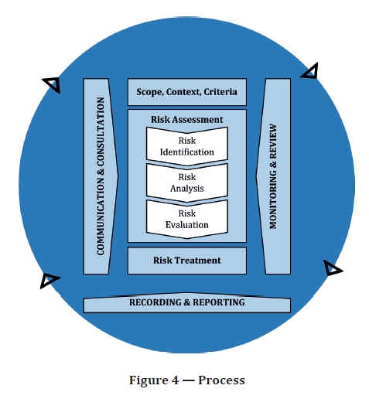
Risk Management Process

Figure 3 – Process (ISO 31000:2018)

The risk assessment and measurement processes allow Wannon Water to consider the extent to which potential events may have an impact on the achievement of its objectives. It encompasses qualitative and quantitative approaches, processes, tools and systems developed and implemented to identify, assess, and measure risks.

This section provides overview of the key steps in the Risk Management process. For further guidance please refer to specific Risk Management procedures available on WaterShed or the Risk and Resilience team.

Communication and Consultation
Communication and consultation should take place during all steps of the Risk Management process with both internal and external stakeholders.

All stakeholders should understand the reasons why decisions are made and why particular actions are required.
Within Wannon Water this could be achieved through:
- Audit and Risk Management Committee
- Executive Committee
- Team meetings
- Risk workshops
- Training in the application of the risk management framework
- Hazard Assessment and Incident Investigation
- Engagement with regulators, government and the water sector

Scope, Context and Criteria

10.2.1 Defining the Scope
Risk Management needs to be a core part of effective business planning and management. A rigorous approach is driven by Senior Management and integrated within all business activities. It should provide a check that we are working to the correct objectives, improve strategic planning and facilitate the design of a control structure.

Risk Management should also be a dynamic process which informs strategic and individual funding decisions. Business planning and risk assessments should be seen as complementary functions. It is vital to assess the events that may affect the organisations ability to meet its key objectives.

The proactive and systematic approach to the identification, analysis and management of risk will have a significant impact on not only the achievement of our objectives but will also provide the opportunity for the organisation to seek out and effectively exploit opportunities that will further enhance the services we provide to our customers.

The risk management process is applied to different levels within Wannon Water.

10.2.2 Risk Types
Strategic Risk: Strategic Risks are events that if occurred would materially affect the achievement of our purpose and strategic intent. They are identified by the Board and Executive and owned by the Executive. The Board via the Audit and Risk Management Committee monitor the risk profile and the status of controls and where necessary risk treatment plans.

The review of Strategic Risks is an integral part of the strategic planning process and informs strategic planning and decision making.

Operational Risk: Operational risks are events that if occurred would affect the achievement of our business as usual. As such these are the risk of loss resulting from the lack of, inadequate or failed internal processes, people and/or systems, or from external events. Operational risk captures risks requiring business continuity plans, environmental risk, crisis management, fraud risks, process systems and operations risk, people related risks and health and safety, and information technology. The risks can be owned by anyone where they have sufficient delegated authority to be able to resource the treatment of the risk.

Project Risk: Project risks impact on the achievement of individual projects, change to processes or programs of work.

They can be identified throughout the stages of the project. Project Managers are expected to implement risk management processes to ensure effective and efficient delivery of projects.

Shared Risk & State Significant Risks: Shared risks (previously known as inter-agency risks) are identified and managed through communication, collaboration and when in our span of control coordinated with impacted agencies.

In addition to the strategic, operational and project level risks, we are required to identify risks that we have identified could contribute to a state significant risk.
If a shared risk or state significant risk is brought to our attention from another agency, Wannon Water will work collaboratively with the identifying agency in analysing and evaluating the risk collaboratively.

In annual reporting to DEECA any reportable risk (Strategic Risks) that could be considered to be contributing to a shared risk, emergency or state significant risk are highlighted.

10.2.3 External and Internal Context
Understanding the context is an important step in the Risk management process.
The external context is the operating environment in which the organisation seeks to achieve its objectives. The external context can include, but is not limited to:

- The social and cultural, political, legal, regulatory, financial, technological, economic, natural and competitive environment
- Key drivers and trends having impact on the objectives of the organisation; and
- Relationships with perceptions and values of external stakeholders

To assist with defining the external context and considering emerging trends and threats we:

- Engage with the water sector and government at a state and national level
- Engage with our regulators
- Engage with customers and the community within our service region
- Utilise the World Economic Forum Annual Global Risk report and access other documents such as the Gartner Quarterly emerging risk report and Melbourne Waters Environmental scan as part of the Strategic planning process

Our context internally is set by our Strategic Direction (Corporate Plan) and our strategies and management plans. The internal context is the business environment in which the organisation seeks to achieve its objectives. This can include, but is not limited to:

- Governance, organisational structure, roles and accountabilities
- Policies, objectives, and the strategies that are in place to achieve them
- Capabilities, understood in terms of resources and knowledge (e.g., capital, time, people, processes, systems and technologies)
- The relationships with and perceptions and values of internal stakeholders
- The organisation's culture
- The organisation’s risk appetite
- Information systems, information flows and decision-making processes (both formal and informal)
- Standards, guidelines and models adopted by the organisation; and,
- Form and the extent of contractual relationships

A Zero Harm approach is an important element of Wannon Water’s risk management philosophy. The Zero Harm approach is an aspiration rather than a defined target. It is a collective mindset and goes beyond the physical safety of people to include mental health and wellbeing and the environments we work in.

It’s Zero harm to people and Zero Harm to our environment.

It sees us empowering our people to:
- Promote safe behaviours in the workplace
- Intervene where necessary to support zero harm outcomes
- Consider environmental impacts
- Be their authentic self in a safe, inclusive workplace

10.2.4 Criteria

Impact Categories
Evaluating the impacts that would be created if a risk became reality is important, as it helps determine if the risk requires treatment and to support decisions.

The consequence categories we utilise to assess risks are:

- Safety
- Service availability
- Environmental
- Water quality
- Reputation
- Financial
- Legal
- IT

Further details on the criteria for the amount of risk we are willing to accept and against which we analyse and evaluate our risks are contained within:
- Risk Policy Statement (and Risk Appetite)
- Risk Permission Statements
- Strategic and Operational Risk Consequence Categories
- RiskWare Risk Assessment module business rules
- Other technical criteria defined within the Risk Management Procedure (e.g., ANCOLD Dam Safety Guidelines)

Risk Identification
Risk identification is a process used to formally identify and record risks that may help or prevent the achievement of objectives. In order to effectively identify risks, it is critical to establish the context and boundaries in which risks will be identified.

A risk exists when a source has the potential to have a negative or positive impact. Risk identification is done at various levels, both within and outside Wannon Water. When identifying risk, consideration should be given to determining:
- Tangible and intangible sources of risk
- Causes and events
- Threats and opportunities
- Who/what specifically is involved in that source (e.g., contractors)
- What consequences would arise from that source (e.g., influence water quality, not deliver on time)
- To what level this would negatively or positively affect each of the impact areas

Sources of Risk
A source of risk is where the risk is originating. Clearly identifying sources of risk is important, as the first approach to treating risk is often to influence the source of risk before it becomes an issue. Using a standard list of sources of risk during identification reduces the likelihood that risks will be missed.

The standard sources of risk used in risk management for Wannon Water are:

- Employees
- Customers and other Stakeholders (Non-Government)
- Suppliers and Contractors
- Regulators
- Government Stakeholders – Federal, State, Local
- Information Technology
- Assets
- Materials
- Processes
- Global Events and Trends
- Natural Events / Climate Change / Extreme / Emergency Events

Risk Evaluation
Risk is analysed by determining consequences or benefits and their likelihood, and other attributes of the risk. An event can have multiple consequences and can affect multiple objectives. All risks (threats) should be assessed across all consequence categories and the most likely outcome (not the worst possible outcome) should be selected.

We will record all measures of consequence and will report on the highest rated consequence.

All risks should be assessed prior to any controls (processes, procedures contingency plans). This is the inherent risk.

Existing controls or future actions and their effectiveness are taken into account when determining the residual risk.

The confidence in the level of risk and its sensitivity to preconditions and assumptions should be considered in the analysis and communicated to appropriate audiences.

Opportunities that are identified should be assessed through the development of a business case.

The purpose of risk evaluation is to help make decisions (based on the outcomes of risk analysis) about which risks need further treatment and their priority.

Risk evaluation involves comparing the level of risk with the risk criteria established when the context was considered.

This can lead to:

- Do nothing further – accept the risk
- Consider risk treatment options
- Undertake further analysis to better understand the risk
- Maintain existing controls
- Reconsider objectives

The outcome of the risk evaluation should be recorded, communicated and validated.

This could be achieved by logging in the Risk register or by way of report to the Executive or Board.

Risk Treatment
Risks are assessed using the relevant risk criteria, appetite and ranked in an order of priority to indicate which risks are within tolerance or otherwise. Risks that fall outside of tolerance may need treatment.

Risk treatment is a risk modification process. It involves selecting and implementing one or more treatment options. Once the risk treatment has been implemented, it becomes a control, or it modifies existing control(s). Risk treatment involves selecting appropriate options for modifying risks, then implementing those options.

Risk treatment options are not necessarily mutually exclusive or appropriate in all circumstances. The options can include:

- Avoid – seeking to eliminate uncertainty by deciding not to start or continue with the activity that gives rise to the threat, or by removing the source of risk.
- Transfer/Share – passing ownership and/or liability to a third party (note this only removes a certain amount of risk, reputational risk normally remains).
- Mitigate – decreasing the likelihood and/or consequence of the threat.
- Accept – recognising residual risk and devising responses to control and monitor them

10.6.1 Selecting risk treatment options
Selecting the most appropriate risk treatment option involves balancing the costs and efforts against the benefits to be gained, with regard to legal, regulatory and other requirements such as social responsibility and protecting the natural environment. Decisions should also take into account those risks that warrant treatment that is not justifiable on economic grounds, e.g. severe (high negative or positive consequences) but rare (low likelihood) risks.

The treatment plan should clearly identify the priority order for individual risk treatments.

Risk treatment can also introduce secondary risks. A secondary risk can be either a new threat or a new opportunity. A significant secondary threat can be the failure or ineffectiveness of the risk treatment.

It is good practice to record a secondary risk as a new risk, and to identify a link within the risk treatment plan that generated it.

When considering existing and future risk treatments, risk assessors should use the Hierarchy of Controls for threats:

- Elimination of the task or item being used Most Effective Option
- Substitution to a less hazardous risk
- Engineering out the risk
- Administratively organising the task or item to diminish the risk
- Insurance Least Effective Option

Safety related (including Drinking water quality) and Environmental operational risks will be managed to reduce the risk “So Far As is Reasonably Practicable. (SFARP) This is in line with our risk appetite statement

Controls should be implemented to reduce the likelihood of the risk occurring and to prevent harm to people, property and/or asset damage and potential liability claims made against Wannon Water.

10.6.2 Risk Treatment Plans
A risk treatment plan documents how the chosen treatment options will be implemented. The information provided in treatment plans should include:

- The reasons for selection of treatment options, including expected benefits to be gained
- Those who are accountable for approving the plan and those responsible for implementing the plan
- Proposed actions
- Resource requirements including contingencies
- Performance measures and constraints
- Reporting and monitoring requirements; and,
- Timing and schedule

The majority of Risk treatment plans will be captured in our risk management software tool and actions should be discussed with appropriate stakeholders. In the rare event that a more formal documented risk management plan is required then this can be prepared in conjunction with the Risk Owner. This will mainly be for larger type projects which involve contractors.

Decision makers and other stakeholders should be aware of the nature and extent of the residual risk after risk treatment. The residual risk should be documented and subjected to monitoring, review and, where appropriate, further treatment.

Risk Response
Risk response can be assessed against the following criteria:
- Appropriate – the correct level of response must be determined, based on the “size” of the risk
- Affordable – the cost effectiveness of responses must be determined to ensure that the amount of effort spent mitigating the threat or enhancing the opportunity does not exceed the “reward”
- Actionable – an action window should be determined within which responses need to be completed
- Achievable – responses must be realistically achievable or feasible
- Assessed – a post-response risk assessment should be carried out to ensure that responses have actually worked
- Agreed – the consensus and commitment of stakeholders should be obtained before agreeing to responses
- Allocated and accepted – each response should be owned and accepted to ensure a single point of responsibility and accountability for implementing the response

Monitoring and Review

10.8.1 Strategic Risks
Strategic Risks are owned and managed by specified General Managers. The health of a strategic risk is monitored through agreed Key Risk Indicators and thresholds.

Strategic Risks are reviewed by the relevant General Manager dependent on the level of residual risk.

Risk Level | Review Period
Low | 12 | Months
Minor | 9 | Months
Moderate | 6 | Months
Major | 3 | Months
Extreme | 1 | Month

This review is undertaken by the Risk Owner in our Risk management software with updates provided to the Audit and Risk Management Committee in the 6 monthly update (see Recording and Reporting section).

Additional oversight and monitoring are undertaken by completion of a “Deep dive” review on a specific Strategic Risk. This is managed and facilitated by the relevant General Manager and involves the Board. Following the Board Deep Dive, items which the Board deem to require further clarification or work are delegated to the Audit and Risk Management Committee for further action and/or review.

The output from these risk and Deep Dive reviews assist with Strategic planning and decision making.

These reviews also inform if any amendments to the risk level or further treatments are required.

10.8.1 Operational & Project Risks
Monitoring and review takes place during all stages of the process.
The monitoring and review methodology is embedded in the relevant Risk Management processes and procedures.

All risks will be monitored. The level of the review will be dependent on the level of the residual risk.
Additionally Risk owners and control owners will be requested to review the risks/ controls whenever there is a trigger (i.e. an incident or audit finding related to either a risk event or a control.)

Recording and Reporting

10.9.1 Strategic Risks
All strategic risks are recorded in the Wannon Water Risk Register.

Key Risk Indicators are developed and continually refined for each of the strategic risks. Management gather and record information pertaining to each Key Risk Indicator for monitoring purposes.

It is the responsibility of the relevant General Manager to ensure that the Board is informed if any of the information recorded triggers an indicator red threshold. The Board report should detail the reason for the indicator being triggered and include actions as to how this is going to be managed or how the risk is going to be treated to reduce either the likelihood or consequence.

Six monthly (May and November) strategic risk trend reporting is provided to the Audit and Risk Management Committee.

10.9.2 Operational Risks
Risk trend data and an assessment of key operational risks will be provided to the Executive Committee on a quarterly basis. This reporting will commence when operational risk workshops commence.

The Audit and Risk Management Committee will be provided with trend data and an overview of key operational risks annually. It is envisaged that this will take place each February.

Key Risk Management Activities
Objective | Activity | Responsibility | Due Date
Annual Reporting to DEECA (Statement of Obligations) | Adhere to the DEECA process for Risk Reporting | Manager Safety Risk and Resilience | April 2024
Adhere to the Ministerial Directions relevant to Risk | Undertake an annual review of the Risk Management framework | Manager Safety Risk and Resilience | February 2025
Review the Risk Appetite Statement | Review the Board Policy Statement for Risk and ensure Risk Appetite Statement remains valid | Executive Strategy and Innovation | November 2024
Embed risk management into the organisation through the integration of the Risk Management Framework | Develop and publish the Zero Harm Management System – Hazard and Risk Management Standard and supporting documentation | Manager Safety Risk and Resilience | November 2024
 | Continue to develop the Operational Risk profile of our sites, facilities and functions – develop Safety, Environment & Water Quality (enterprise risks in RiskWare) | Manager Safety Risk and Resilience | December 2024
Provide practical mechanisms and process for staff to implement the risk process | Develop training/guidance materials and tools to enable the risk assessment process | Risk and Resilience Team | December 2024

References
- ISO 31000 Risk Management Guidelines
- Department of Treasury and Finance Standing Directions of the Minister for Finance 2018 (revised December 2019) (under the Financial Management Act 1994)
- Ministerial Standing Direction 3.7.1 – Risk management framework and processes
- Ministerial Standing Direction 3 Governance
- Section 41 (2) Water Industry Act 1994 Statement of Obligations (2015)
- Part 5 – Risk Management
- Department of Treasury and Finance (July 2018) Victorian Government Risk Management Framework – August 2020
- ISO 14001 (Environment) and ISO 45001 (OHS) – 6.1 Actions to address risks and opportunities

Being developed as part of the Zero Harm Management System implementation program

